TEAM A

Design Document – J.U.N.I.O.R.

Team A: David Emerson, John Berg, Eric Cowan, Orlando Camacho
GSP494 – Senior Project I
Professor David Horachek
10/09/2013

Contents
TITLE: 3
DESCRIPTION/FEATURE SET: 3
PURPOSE/APPLICATION: 3
PREMISE: 3
GENRE: 3
PLATFORM: 3
TARGET MARKET: 3
TARGET RATING: 4
PLAYER MODE: 4
TIME INTERVAL: 4
BACKSTORY: 4
CHARACTER DESCRIPTION: 5
COMPETATIVE ANALYSIS: 5
RULES: 5
Number of Players 5
Age Range 5
Approximate Time of Play 6
Victory and Loss Condition 6
Scoring 6
Game play 6
CHALLENGES 6
STRATEGIES 6
THEORY/GAME BALANCE 7
PERSPECTIVE/GAME VIEW 7
USER INTERFACE 7
ART 7
AUDIO 9
SUMMARY/FUTURE UPDATES 9
Sources 10

TITLE: J.U.N.I.O.R.
This is sort of a comical play on all the ridiculously long acronyms used in the electronics field.

DESCRIPTION/FEATURE SET:
In this game you play as Jr.; a highly advanced, and heavily armed, observational robot programmed to explore the stars in search for alien life. Fight against an array of killer robots from the hordes of Dr. Sinister, who is on a quest to discover alien life before you do so that he may conquer them and claim their resources. Employ an array of weaponry and special abilities, to include:

- Ion-pulse thrusters for hovering to get those hard-to-reach baddies
- Charged plasma force fields to protect against enemy fire
- Powerful twin laser blasters to cut through enemies

PURPOSE/APPLICATION:
The purpose is to have fun blasting through hordes of enemies and to discover alien life before Dr. Sinister does. Collect various weapons to do more damage to your enemies. It is a race to save outer space from an evil scientist whose only desire is to control the galaxy!

PREMISE:
Search the cosmos to answer the age-old question: are we alone in the universe? We may know soon. But be careful… you’re not the only one looking!

GENRE:
Third Person Adventure Game with one main goal: find alien life before Dr. Sinister!

PLATFORM:
This game will be open to mainly PC. The idea is to offer the game as a download and possibly have a version that is playable through a web browser at a later date. New levels and upgrades may also be offered periodically via download.

TARGET MARKET:
The target audience will be both children to young teenagers and people who remember platform games from the late ‘90s to early 2000's. No graphic violence will be incorporated as most of the enemies are from a mechanical army so children will not be subjected to inappropriate material. The style of the game will be similar to "Jak and Daxter (Sony Computer Entertainment)" for PS2™.

TARGET RATING:
Everyone will be able to enjoy this game. The only violence in this game will be the destruction of various machines, and there will be no obscene language or behavior, so it is doubtful the ESRB would give a higher rating than "E for Everyone".

PLAYER MODE:
There is only a single player mode for this game. The player will progress from one level to the next, when they have destroyed all of the enemy machines on that level (rather than just make it to the end of the level—remember we are trying to stop Dr. Sinister from finding alien life). You will have a single energy meter that measures several things:
- Ammunition for your weapons
- Thruster power (thrusters will not be available below 20% energy
- Shield power (also not available below 20% energy
- And most importantly, life—once your energy meter reaches zero you can no longer move and must restart the level
Energy will be replenished by killing enemies and collecting their power supplies, or by reaching a power source such as a generator or reactor. Bonus items may be collected to upgrade your weapons, but more powerful weapons consume more energy (don’t worry, you will be able to cycle through your weapons to choose a lower consumer). There will also be a power upgrade that the player may find that will upgrade Jr.’s power generator from the standard micro-fusion cell to an anti-matter power cell, increasing the length of time between recharges.

TIME INTERVAL:
There will not be a passing of real time. Time will pass only as the player progresses to the next level.

BACKSTORY:
The year is 2100 and we have yet to discover other life in the galaxy as our own human exploration has not reached much past Mars. In an attempt to broaden the search for extraterrestrial life, Earth scientists created J.U.N.I.O.R., the Joint Universal “Neo-Intelligence” Observational Robot. “Neo-Intelligence” refers to a new advanced form of AI which uses a quantum-computer to process algorithms at a rate that simulates human behavior.

Jr. would be loaded into a long-range space vessel and launched into space. His mission and programming would be to examine scanned data of star systems to determine the most likely places to search for life. If “he” (the simulated personality is that of a male) were to find life, he would document and transmit the information back to Earth.

One month after Jr. is launched he learns that a mad-man named “Dr. Sinister” has broken into the laboratory where he was made and has stolen plans to various advanced robotics and equipment and intends to use the technology to beat Jr. and the scientists to the punch by discovering alien life first, then using up any resources they have in his quest for galactic domination.

Jr., capable of reprogramming himself (with certain limitations) to fit the situation at hand, changes his mission to not just discover alien life, but to reach it before Dr. Sinister in order to protect it.

CHARACTER DESCRIPTION:
The only playable character is J.U.N.I.O.R., an advanced research and exploration robot designed to discover alien life in the galaxy. He is quirky and has a sense of sarcasm, but lacks human emotion, so his humorous anecdotes are only appreciated by others.
The main antagonist is Dr. Sinister. He is a maniacal genius who stole advanced technology in order to launch his quest to conquer the galaxy and use its resources for his own bidding.

Columbus is Jr.’s vessel. He lets Jr. know of certain dangers, sends in occasional power-ups, and acts as a guide to Jr.

COMPETATIVE ANALYSIS:
"Jak and Daxter (Sony Computer Entertainment)" is a 3D adventure game where two crazy characters have to fix the world because a substance called "Dark Eco" getting into villains hands. There are several different machines that they use to make their way from place to place and it provides a comedic adventure.

"Ratchet and Clank (Sony Computer Entertainment)" also has a dynamic duo that has to save the universe from evil villains. The world is similar to our own but has some advancements and one of the characters is a "Lombax" and the other is a robot. Some installments of Ratchet and Clank have an experience system where the player can upgrade their weapons and health.

J.U.N.I.O.R. will have a similar duo feel to it as Columbus will be with Jr. letting him know of dangers. The two games mentioned before have a puzzle aspect to them while J.U.N.I.O.R. will be all adventure and stopping the evil villain Dr. Sinister. The way that weapons will change and health will be upgraded is by strategically placed power-ups that the player can get by colliding with them.

RULES:

Number of Players: Single player only.

Age Range: This game is suitable for all ages.

Approximate Time of Play: Approximately 3-5 minutes per level.

Victory and Loss Condition: The victory condition takes place when you destroy all required enemies on a given level. Loss is exactly the opposite—the enemies defeat you. There is only 1 life (your energy bar) so use your energy wisely.

Scoring:
Scoring will be simple: you will receive points for each enemy you defeat. After achieving enough points, you will receive a power up dropped from above by your ship.

Game play:
You will go against Dr. Sinister and his minions and must defeat them all in order to save the galaxy from domination. The rules are very easy: destroy the enemy. You will have to manage your energy meter as all of your resources consume energy. More powerful weapons use more energy, so you have to balance that out. There will be three levels upon initial completion: level 1 will be right after Jr. lands on a planet and finds Dr. Sinister’s forces. There is only 1 type of enemy for this level. Once the player defeats all of the enemies in the level a door will open up in a building, allowing you to enter. Don’t forget to look for your weapon power up for this level, as it will make the next level much easier. Now you will proceed to level 2 which is inside a building where Jr. suspects Dr. Sinister is deciding which planet to search next for life. You will encounter additional enemies in this level and must destroy them all. This level is also where the secret anti-matter power cell is hidden. Level 3 is where you fight Dr. Sinister. If the player did not find the power cell from level 2 this fight will be a little more difficult, but not impossible. After defeating Dr. Sinister, he escapes. But you will have defeated many of his minions. This leaves room for future levels to be added.

CHALLENGES:
The challenges will be killing all the enemies and making it to the next level without depleting all of your energy meter. If your meter reaches zero you will shut down and must play the level over again.

STRATEGIES:
The best strategy is to look for all of the power-ups. On the first level there is a lightning power-up, allowing Jr. to zap a bolt of electricity vertically, damaging enemies above him. This is important as some of the enemies on the next level are on the ceiling. Since Jr.’s laser cannons only shoot forward, the player would have to use the thrusters to hover high enough to destroy these enemies. Doing this would significantly deplete your energy meter.

On level 2 the upgraded energy supply, the anti-matter cell, is hidden somewhere. The player also receives the pulse cannon power-up on this level which may lead them to believe that it is the only power-up available here. However, the power cell is hidden and is necessary in order to effectively use the pulse cannon (as the cannon consumes massive amounts of energy on the standard power cell).

On level 3 the player must fight Dr. Sinister. He will be in a super machine that has 3 main attacks, 2 of which fire on a rotational basis. The first attack is a standard energy ball, similar to that fired by most other enemies, which will be fired toward Jr. The second attack is a massive energy beam which fires in a straight line across the room. He will rotate between these two attacks. For the third attack, he will launch cannon discs on a regular basis which will bounce around the room and start firing at you. Since the discs will continue to multiply, the player must make sure to eliminate as many as possible (note that the energy cell from the discs will add to Jr.’s energy meter). This is where having the pulse cannon comes into play—the cannon’s shots will pass through every enemy in its path, damaging multiple enemies, all the while still doing damage to the boss.

THEORY/GAME BALANCE:
The balance of this game hinges on the energy meter. The player must be able to balance their desire to use powerful weapons, thrusters, and shields with the need to conserve energy to make it to the next level. If a player uses the shield then they may be able to survive a few shots from a turret, but they will also be rapidly depleting their power reserves. The same will result from using the lightning or pulse cannon too much.

PERSPECTIVE/GAME VIEW:
The view will be from the side only for this game. You will view a 2D portrayal of Jr. and his environment and you will only see the area around Jr. as the view will move as he does.

USER INTERFACE:
The controls will be rather simple and will use the keyboard. The left and right arrow keys will control Jr.’s movement, the up arrow will activate his thrusters, the down arrow will activate his shield, and the space key will fire whichever weapon is selected.

The interface will consist of 3 items: the energy meter which will start at the top left side of the screen and will go about 2/3 the way to the right side. Immediately to the right of the energy meter will be the current score, then the current selected weapon. There will be a background to the UI that will change based on what power cell you have equipped. If you are using the standard fusion cell, the background will be red. If you have the upgraded antimatter cell, it will be blue. This will allow the player to know how much energy they have at their disposal.

ART:
The art in J.U.N.I.O.R. will be futuristic and all characters that will be shown are robots. All levels will be on planets other than Earth.

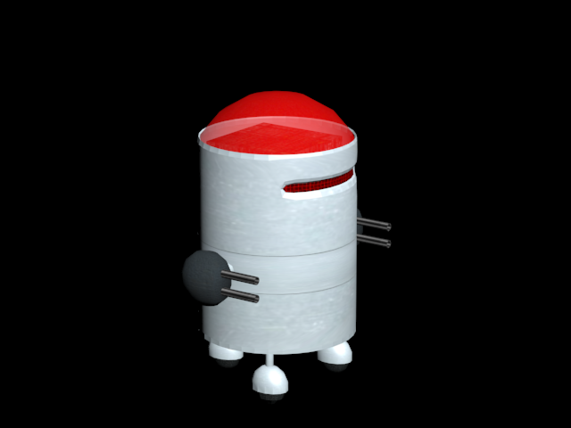

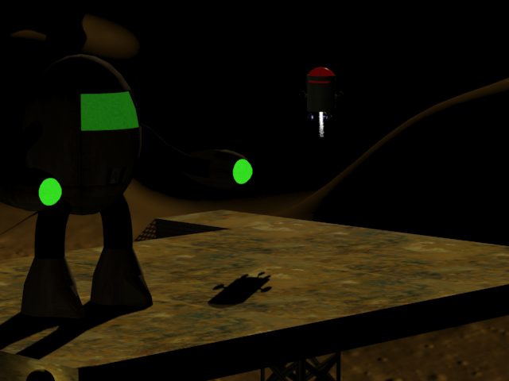
AUDIO:
The audio will be simple sound effects, such as laser and explosion sounds. Music will be somewhat mystical to reflect the fact that it is a different world. For the final boss fight where the player faces off against Dr. Sinister, the music will quicken into something suspenseful.

SUMMARY/FUTURE UPDATES:
This game will be a fun afternoon break, allowing the player to step away from reality and play the part of an exploring robot. Unique weapons and upgrades, and the power management system will make it fun to see how many different ways there are to win.

There may be more levels, weapons, and upgrades available in the future, as well as a possible adaptation to portable gaming devices and/or smart phones since the internet is readily available for downloading the files.

Sources
Sony Computer Entertainment(N.D.) Jak and Daxter Series.
Sony Computer Entertainment(N.D.) Ratchet and Clank Series.
PS2 is a registered trademark of Sony Computer Entertainment. All rights are reserved by Sony Computer Entertainment.

